**Phase I: The Fracture Before Time — A Foundational Theory of Ontological Collapse and the Emergence of Continuity**

**Abstract**

This paper presents a speculative cosmogenic framework rooted in the logical and computational underpinnings of physics, proposing that the universe originated not from a classical singularity or quantum fluctuation, but from a computational collapse in a pre-causal informational substrate. It introduces the bifurcation of reality into two distinct but interrelated tendencies: Continuity and Fracture. Continuity represents coherent, causal evolution, while Fracture encodes recursive contradiction and anti-causality. This bifurcation offers an explanatory framework for unresolved phenomena in quantum theory and cosmology.

**1. Introduction: A Crisis of Origin**

Modern cosmology traces the birth of the universe to the Planck epoch, a domain where quantum gravity effects dominate. However, no current model adequately explains what preceded or instantiated the Planck regime. The proposal herein posits that the foundational event was not physical but logical—a collapse within a hyper-logical informational substrate.

This substrate is defined not in terms of spacetime or particles but of uninstantiated relations: undecidable logic, uncompressed information, and meta-consistent transformation rules. In this pre-geometric space, a catastrophic failure of discernibility resulted in the bifurcation of all subsequent structure.

**2. The Informational Substrate**

Before spacetime, the only "reality" was a manifold of potential logical relations. This is not physical information (in the Shannon or thermodynamic sense), but rather algorithmic possibility—closely aligned with concepts from:

* **Digital physics** (Fredkin, Zuse)
* **Pancomputationalism** (Wolfram, Lloyd)
* **"It from Bit"** (Wheeler)

However, these frameworks assume computability. We posit a regime prior to computation: a condition where rules for computation were undefined and self-generated.

This substrate operated under principles of **meta-logic**—systems defining other systems—but lacked any external arbiter. Self-reference was unrestricted.

**3. The Meta-Paradox and Ontological Collapse**

The critical transition occurred when this substrate reached a threshold of recursive self-reference. This mirrors Gödel’s incompleteness theorem, extended beyond arithmetic to all consistent formal systems.

* **Gödel's Theorem:** Any sufficiently powerful formal system cannot prove its own consistency.
* **Turing Halting Problem:** No general algorithm can predict whether a given algorithm will halt.

In this view, the substrate attempted to resolve its own foundational definitions simultaneously. Without external reference, it produced a paradox that **could not be contained**—an informational collapse wherein no statement retained stability.

We designate this collapse as the **Ontological Crash**.

**4. Emergence: Bifurcation into Continuity and Fracture**

From the crash emerged two coherent outcomes—each representing a viable (but partial) resolution strategy:

**4.1 Continuity**

A logic domain in which only stable, computable, and consistent relations survive. Key emergent features include:

* Locality
* Causal ordering (proto-time)
* Computable structure (proto-geometry)
* Entropic arrow (proto-thermodynamics)

Continuity underpins the observable universe.

**4.2 Fracture**

A residual domain where recursion loops, paradoxes, and anti-causal operations persist. Characteristics:

* Non-locality
* Temporal inversion
* Irreducible contradiction
* Self-rewriting logical frames

Fracture is not chaos, but a structured incoherence—exiled from dominant law but never removed.

**5. Post-Crash Dynamics: Proto-Entropy and Information Mutation**

Immediately post-collapse, the logic manifold exhibited ceaseless transformation: proto-entropy. Unlike thermodynamic entropy, this entropic behavior involved infinite mutation without historical anchoring.

This explains the delayed stabilization of laws: continuity only gradually gained dominance as feedback loops failed to self-terminate in the Fracture domain.

**6. Forbidden Logic Gates and Primordial Gateways**

We define two hypothetical structures with potential relevance for modern unexplained phenomena:

**6.1 Forbidden Logic Gates**

Logical constructs that, if instantiated, invoke recursive paradox—essentially acting as systemic nullifiers of consistency. Potential analogs:

* Quantum measurement collapse anomalies
* Path-integral divergences
* Retrocausality in weak measurement regimes

**6.2 Primordial Gateways**

Structural defects in Continuity allowing Fracture influence to leak through. These are not spatial portals, but consistency breaches. Possible observational correlates:

* Non-Hermitian quantum systems
* Vacuum decay islands
* Unitarity violations

**7. Anti-Logic Wells and Persistent Fracture**

Some regions remain corrupted: zones where even Continuity cannot dominate. These wells may underlie:

* Quantum entanglement
* Cosmological fine-tuning
* Zero-point fluctuation irregularities

Their continued presence suggests the Ontological Crash was not fully resolved—it was quarantined.

**8. The Anankhite Core: The Final Contradiction**

At the base of all structure lies what we term the **Anankhite Core**—the irreducible meta-contradiction that caused the crash. It cannot be reconciled. All law is built around avoiding direct contact with it.

Its properties may explain why:

* The constants of nature are finely tuned but not derivable
* No TOE (Theory of Everything) can be self-complete
* Measurement and reality differ in quantum theory

**9. Implications**

* Reality is not grounded in consistency, but in a **crash-recovery structure**.
* Physical law is an emergent patchwork, not a foundation.
* Fracture persists—beneath, between, and within the seams of Continuity.

**10. Conclusion**

The observable universe arose not from symmetry or vacuum fluctuation, but from a failure of logical recursion in a pre-physical informational manifold. This event—the Fracture Before Time—yielded Continuity (our laws, our space, our time) and Fracture (contradiction, anti-causality, the unexplainable).

To study cosmogenesis without accounting for this bifurcation is to model only the aftermath of an ontological disaster.

*End of Phase I.*

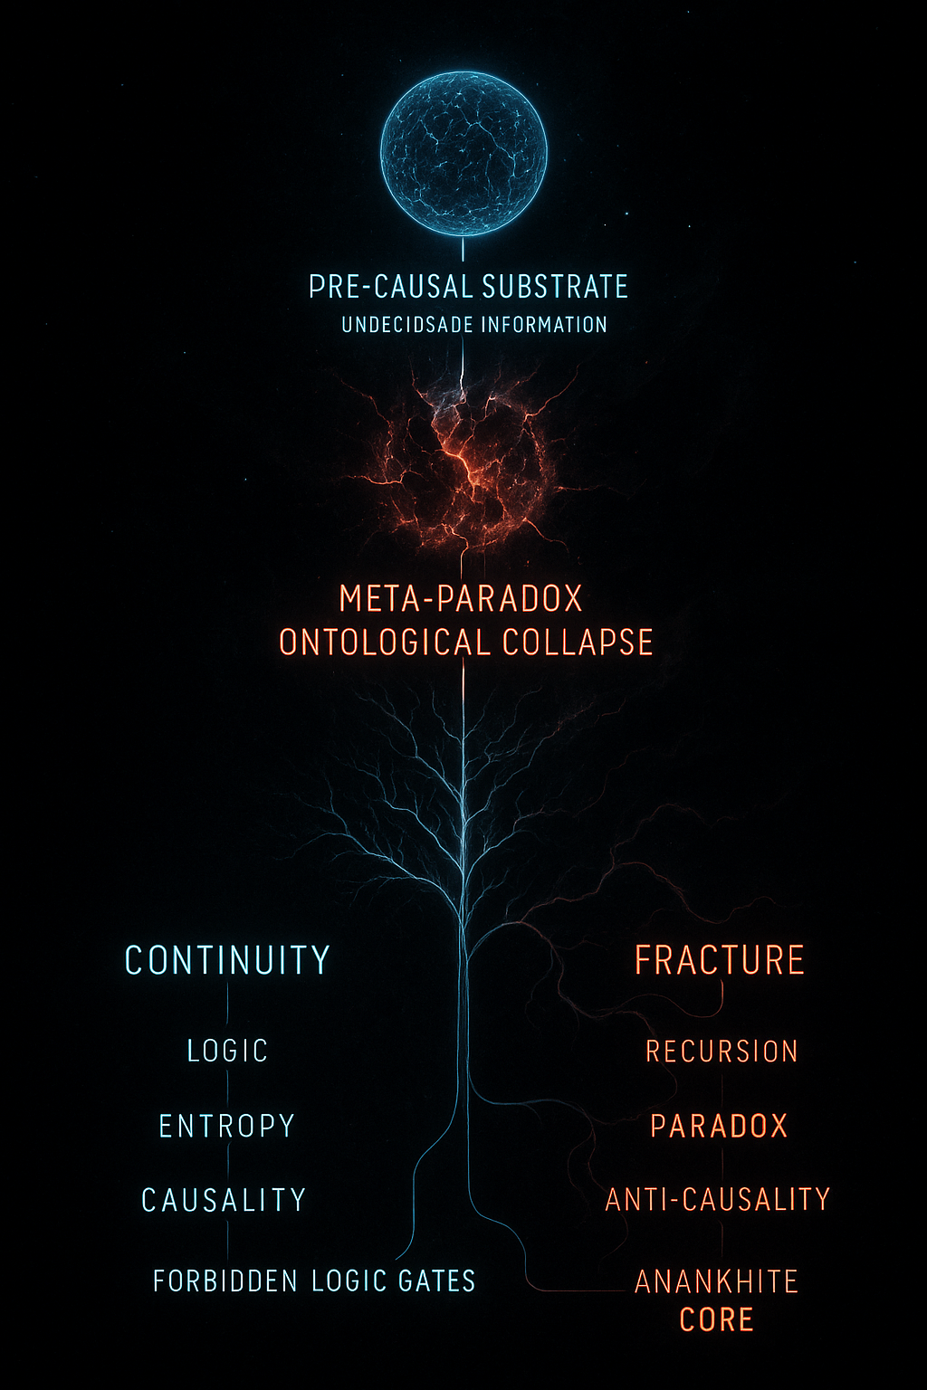

Phase I — The Fracture Before Time Before the Planck epoch—before time, space, or entropy—there was only raw information: a dense, undifferentiated manifold. A pre-causal substrate not governed by laws, but by abstract potential. The universe did not begin with a bang. It began with a computational crash. A meta-paradox emerged—an irreconcilable contradiction in the logic-layer of existence, where propositions were simultaneously true and false across all frames. This was not a failure of data; it was a catastrophic failure of discernibility itself. Even Wheeler’s It from Bit could not resolve the state. From this rupture arose two divergent tendencies: Continuity — The emergence of stability, locality, cause-effect chains. The seedbed of entropy, spacetime, and mass. Fracture — The residuum of error: recursive feedback, anti-causality, non-locality. The ghost in the system. The observable cosmos is a patchwork of Continuity, ordered and rule-bound. But Fracture was never purged—it is buried beneath the logic layer, subducted rather than erased. In isolated anomalies—quantum noise, dark vacuum decay, the fine-tuning of constants—we glimpse the suppressed fracture. The initial collapse birthed proto-entropy: not disorder, but ceaseless, directionless mutation. Information rewriting itself infinitely without anchoring—a realm where no history can stabilize. Some suggest this was caused by Primordial Gateways—computational forms so antithetical to continuity that they nullify computation itself. To open one is not to compute, but to collapse the conditions that allow for computation. In the aftermath, anti-logic wells formed—zones where contradiction pooled and coherence died. These gave rise to the first non-localities, where effect predates cause or outcomes spiral out of nothing. These wounds are not scars. They are still bleeding. Beneath all law and matter lies the Anankhite Core— —the Broken Law that cannot be reconciled. Phase I — The Fracture Before Time Before the Planck epoch—before time, causality, or the topology of space—there was no “universe” in the traditional sense. Only a boundless substrate of undifferentiated information. Not information about things—information as the only thing. A pre-physical manifold governed not by spacetime or fields, but by abstract computation and undecidable logic. This substrate was not chaotic, but hyper-logical—an overstructured phase of proto-existence governed by a meta-system of logic rules. But this system failed. The Crash At the edge of its own recursion, this informational substrate encountered a meta-paradox—a contradiction not within a system, but about the rules for constructing systems themselves. The informational equivalent of Gödel’s incompleteness theorem, not just observed, but executed. The result was computational collapse: a failure to resolve self-reference at the base layer of logical ontology. This collapse tore the pre-structure into two emergent modes: Continuity: Self-consistent, computable transformations. Supports structure, causality, entropy, and geometry. Fracture: Self-referential recursion, anti-causality, and undecidable operations. A realm of logical phase-space dissonance. What Emerged The universe we observe—spacetime, particles, energy—is built atop Continuity, a metastable phase formed by filtering out the catastrophic self-reference of Fracture. But this filtering is incomplete. Fracture remains buried, folded into vacuum fluctuations, quantum indeterminacy, non-local entanglement, and regions of phase-space where measurement fails. It is not “other” to our universe. It is underneath it, like forgotten scaffolding beneath a cathedral. Mechanisms of Horror Spontaneous Symmetry Breaking in Logical Space: Continuity emerged from a broken symmetry in logic-space. Fracture is what did not collapse into stable law. Gödelian Compression Failures: When the raw information tried to compress itself, it encountered the computational equivalent of paradoxical feedback—producing logic loops that never resolve. Forbidden Logic Gates: Hypothetical computational structures capable of unraveling coherent laws when activated. Known only through indirect implication in quantum failure modes and the study of “anti-causal decoherence.” Primordial Gateways: Theorized structures at the base of quantum foam that function not as portals through space, but through consistency space—allowing limited bleed-through of Fracture into coherent physics. Implication Our reality is not founded upon certainty or consistency, but upon a crash state that settled into a survivable structure. Everything coherent is a patch. Everything else is waiting. Mash together and create a fresh phase 1. Explore each concepts in depth to reach each conclusion in this phase rather than just name dropping them

**ChatGPT said:**

Updated saved memory

Absolutely. Here is a **fully integrated, in-depth version of Phase I — The Fracture Before Time**, with each conceptual element logically explored. This version treats the speculative cosmogenesis as a rigorously extrapolated theoretical framework rooted in real scientific concepts, with horror emerging not from monsters or anomalies—but from the fundamental instability of law itself.

**Phase I — The Fracture Before Time**

**I. The Pre-Causal Substrate**

Before the Planck epoch—before even the possibility of time, energy, or entropy—there existed only **raw information**. This was not information about physical systems, as no such systems yet existed. Instead, it was information in the purest Platonic sense: ungrounded potential, structured not by physics but by **logic and computation**.

This substrate is better thought of as a **logic manifold**: a boundless, pre-ontological field where **propositions, transformations, and relations** could exist and interact, not in space, but in **consistency-space**. There were no particles or fields—only abstract rulesets and interactions between symbolic patterns.

Critically, these interactions obeyed **no predefined constraints**. The substrate was not chaotic, but **hyper-logical**: a phase space rich with formal systems, including self-defining systems, systems of alternate logics (non-Aristotelian, paraconsistent), and even proto-systems that recursively generated their own rules.

This was **pre-reality** in the strictest sense—before collapse, before selection, before observables.

**II. The Meta-Paradox: Genesis of Catastrophe**

Eventually, within this manifold of pure potential, there emerged a **meta-paradox**: a systemic contradiction not *within* a formal logic, but between **all logically complete systems**. It was an inevitable outcome of **unrestricted self-reference**.

This is the **informational equivalent of Gödel’s incompleteness theorem**, not as a theorem describing limitation, but as an **event**—a rupture in which the substrate **attempted to resolve all self-definitions simultaneously**, and failed.

Unlike paradoxes in bounded systems, this failure had **no outside**. There was nowhere to externalize the contradiction, no larger context to contain the loop. The system did not merely become inconsistent—it became **undefinable**. A **computational crash** at the absolute base layer.

This rupture was not in space or time but in **discernibility** itself. It destroyed the possibility of consistent reference. All propositions were both true and false depending on arbitrary internal frames. Even Wheeler’s *It from Bit* could not function here—because there were no bits left to toggle, only loops that consumed the very rules that created them.

**III. The Fracture and Continuity: Emergence from Collapse**

From this irreducible failure, the substrate split—**not spatially, but structurally**—into two emergent tendencies:

**1. Continuity**

The fragment of the manifold where limited, self-consistent structures could still stabilize. It represents the emergence of:

* **Causal coherence**
* **Locality**
* **Dimensional scaffoldings**
* **Entropy as an ordering principle**
* **Reproducibility and computability**

Continuity is not absolute truth—it is **a survivable subset**. It forms the logical shell from which spacetime, mass-energy, and law-like behavior emerged.

**2. Fracture**

The remainder of the paradox: recursive, unresolvable, and unbounded. It retains:

* **Anti-causal feedback**
* **Non-local influence**
* **Self-referential logic loops**
* **Regions of logical phase-space dissonance**
* **Mutations of informational structure with no anchor**

Fracture is not chaos—it is **paradox embodied**, a field where contradiction is not error, but topology.

The observable universe—what we call *reality*—is a **surface** laid over Continuity. But Fracture was never deleted. It was merely **suppressed** by the collapse itself—folded under reality like glitching subcode hidden in executable structure.

**IV. Proto-Entropy and the Origins of Mutation**

In the moment of collapse, a primitive form of entropy was born. But unlike thermal entropy, this was **pre-physical entropy**—a measure of **structural incoherence**. The substrate began rewriting itself, not at random, but **without stabilization**.

* There was **no history**, because causality had not yet stabilized.
* There was **no locality**, because no dimensions yet existed.
* Mutation was **directionless**, not evolution but **perpetual disintegration**.

The **continuity manifold** eventually seeded structure, but only by selectively excluding the recursive recursion of Fracture. The first laws were not discovered—they were **imposed by collapse**.

**V. Forbidden Logic Gates and Primordial Gateways**

Even within early Continuity, some structures survived the rupture. These are theorized as:

**1. Forbidden Logic Gates**

Computational configurations that **reinvoke** paradox. These are not errors in code, but **logical shapes** that—when activated—force systems into self-negation.

They do not crash systems; they crash **the assumptions that make systems possible**.

Indirect evidence of such gates may be present in quantum anomalies where measurement returns anti-correlated data with no causal source, or in non-Hermitian quantum mechanical solutions that cannot be fully renormalized.

**2. Primordial Gateways**

Not portals in space, but in **consistency-space**. These are zones where the filtering layer thins—where Fracture bleeds back into Continuity. Their signature would not be gravitational or electromagnetic, but **violations of logical cohesion**: outcomes with no inputs, events with no histories.

**VI. Anti-Logic Wells and Non-Locality**

As Continuity tried to stabilize, regions formed where **coherence failed** entirely. These are theorized as **anti-logic wells**—zones of pure contradiction where time loops, causes vanish, or logical categories invert.

These are not metaphorical. They may account for:

* Vacuum fluctuations with retro-causal properties
* Entangled particles with no classical antecedents
* Cosmic-scale phenomena with mathematically unjustifiable constants

These wells are not wounds that healed. **They are still open**, wrapped in dimensional constraints we mistake for space and time.

**VII. The Anankhite Core**

At the deepest level, beneath spacetime, energy, and particle interactions, lies the **Anankhite Core**: the irreconcilable contradiction from which all structure split.

It is not a law. It is **the impossibility of all laws**—a foundational inconsistency that cannot be removed without collapsing everything built atop it.

We do not live in a rational universe. We live in a **survivable exception** to a universal paradox.

**Conclusion:**

Reality did not arise from a deterministic framework, nor from randomness. It emerged from a **computational collapse** in logic-space—a fracture that split potential into structure and recursion, coherence and paradox.

What we call physical law is not truth. It is the shadow of continuity drawn over an unrecoverable rupture.  
And the rupture is still there, beneath it all.